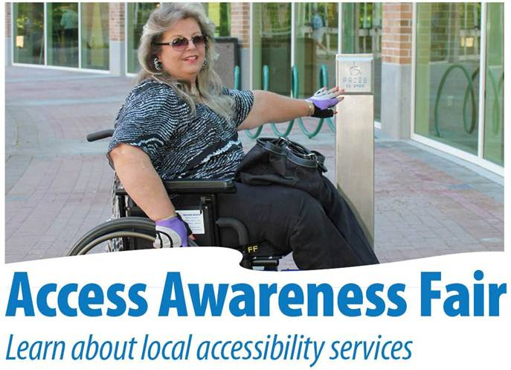
When: Saturday, June 15, 2013
Where: Recreation Complex, Wellness Room, 300 Ioco Road, Port Moody
Time: 10 am - 4 pm
- Celebrate Access Awareness Day at Port Moody to raise awareness about disability, accessibility and social inclusion.
- The Fair features organizations & businesses that provide a wide range of services for the Disabled & Elderly in the Tri Cities.
- Learn what your community has to offer.
- Enjoy demonstrations, refreshments, door prizes and more.
- Watch BC Wheelchair Basketball demonstrations/game in the Rec Center
- Watch a film "Hope Is Not A Plan" in the City Hall, Parkview Room, Two showings, 1 pm & 2:30 pm
- Organized by the Port moody Community Care Committee.

